# Assignment 4

Consider the following schema of a relational database:

Branch (branch_name, branch_city, assets)

Customer (customer_name, street, city)

Loan (branch_name, loan_no, amount)

Borrower (customer_name, loan_no)

Account (branch_name, account_no, balance)

Depositor (customer_name, account_no)

Create table through appropriate SQL commands. Define all integrity constraints and enter sufficient data.

Write SQL commands for the following queries.

1. Give the customer name who has account but not any loan
2. Give the name of the customer who has either (10000-20000) or (30000-40000) in their account.
3. Which branch has issued maximum amount of loan?
4. Give the name of the customer who has maximum balance in their account.
5. Give the name of the customer who has opened an account in a city in which he is not located.

# Solution

## Table creation

### Branch

create table branch(branch_name varchar2(15) primary key, branch_city varchar2(15), assets int);

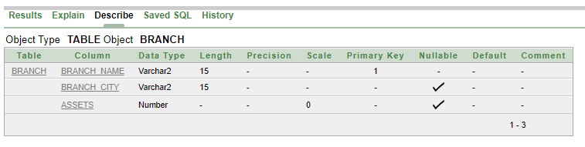

### Customer

create table customer(customer_name varchar2(10) primary key, street varchar2(20), city varchar2(15));

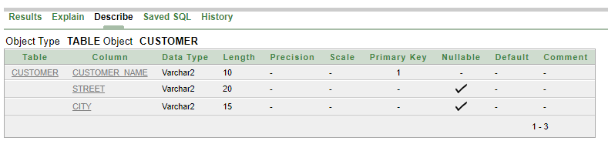

### Loan

create table loan(loan_number varchar2(4) primary key, branch_name varchar2(15), amount int);

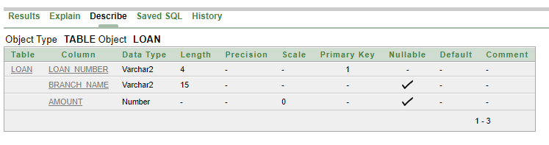

### Borrower

create table borrower(customer_name varchar2(10), loan_number varchar2(4) , primary key(customer_name, loan_number), foreign key(customer_name) references customer(customer_name), foreign key(loan_number) references loan(loan_number));

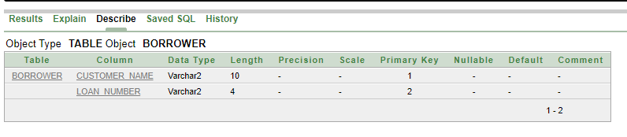

### Account

create table account(account_no varchar2(5) primary key, branch_name varchar2(15), balance int);

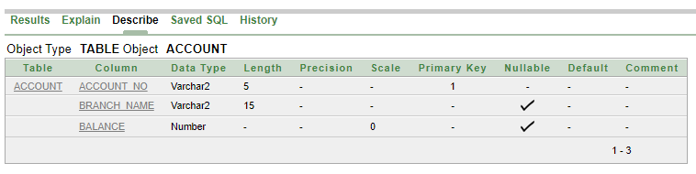

### Depositor

create table depositor(customer_name varchar2(10), account_no varchar2(5), primary key(customer_name, account_no), foreign key(customer_name) references customer(customer_name), foreign key(account_no) references account(account_no));

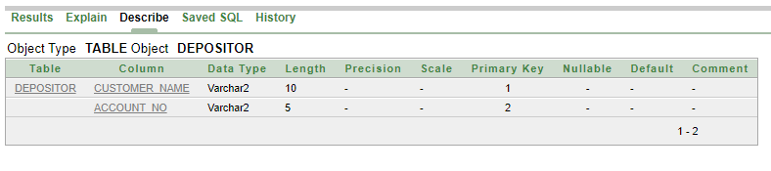

## Value insertion

### customer

insert into customer values(‘Johnson’, ‘12 Amla St.’, ‘Palo Alto’);

insert into customer values(‘Smith’, ’4 North St.’, ‘Rye’);

insert into customer values(‘Curry’, ’16 North St.’, ‘Rye’);

insert into customer values(‘Hayes’, ’3 Main St.’, ‘Harrison’);

insert into customer values(‘Turner’, ’123 Putnam Ave.’, ‘Horseneck’);

insert into customer values(‘Jones’, ’100 Main St.’, ‘Harrison’);

insert into customer values(‘Lindsay’, ’175 Park Ave.’, ‘Palo Alto’);

insert into customer values(‘William’, ’8 Nassau Ave.’, ‘Princeton’);

insert into customer values(‘Adam’, ’14 Spring St.’, ‘Pittsfield’);

insert into customer values(‘Jackson’, ’5 Dupont Ave.’, ‘Woodside’);

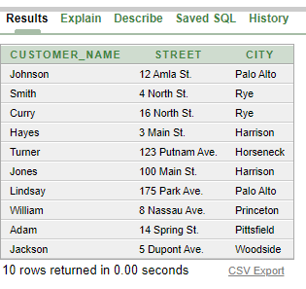

### Branch

insert into branch values(‘Brighton’, ‘Brooklyn’, 7100000);

insert into branch values(‘Downtown’, ‘Brooklyn’, 9000000);

insert into branch values(‘Mianus’, ‘Horseneck’, 400000);

insert into branch values(‘North Town’, ‘Rye’, 3700000);

insert into branch values(‘Perryridge’, ‘Horseneck’, 1700000);

insert into branch values(‘Pownal’, ‘Bennington’, 300000);

insert into branch values(‘Redwood’, ‘Palo Alto’, 2100000);

insert into branch values(‘Round Hill’, ‘Horseneck’, 8000000);

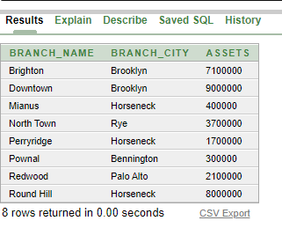

### Account

insert into account values(‘A101’, ‘Downtown’, 50000);

insert into account values(‘A102’, ‘Perryridge’, 40000);

insert into account values(‘A201’, ‘Brighton’, 90000);

insert into account values(‘A215’, ‘Mianus’, 15000);

insert into account values(‘A217’, ‘Brighton’, 75000);

insert into account values(‘A222’, ‘Redwood’, 25000);

insert into account values(‘A305’, ‘Round Hill’, 35000);

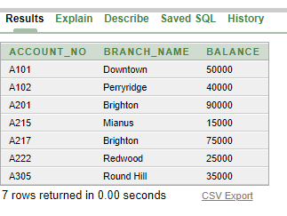

### Depositor

insert into depositor values(‘Hayes’, ‘A102’);

insert into depositor values(‘Johnson’, ‘A101’);

insert into depositor values(‘Johnson’, ‘A201’);

insert into depositor values(‘Jones’, ‘A217’);

insert into depositor values(‘Lindsay’, ‘A222’);

insert into depositor values(‘Smith’, ‘A215’);

insert into depositor values(‘Turner’, ‘A305’);

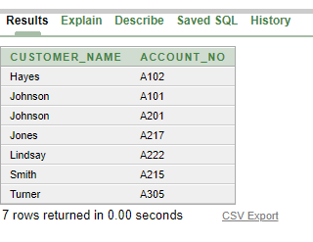

### Loan

insert into loan values(‘L11’, ‘Round Hill’, 900);

insert into loan values(‘L14’, ‘Downtown’, 1500);

insert into loan values(‘L15’, ‘Perryridge’, 1500);

insert into loan values(‘L16’, ‘Perryridge’, 1300);

insert into loan values(‘L17’, ‘Downtown’, 1000);

insert into loan values(‘L23’, ‘Redwood’, 2000);

insert into loan values(‘L93’, ‘Mianus’, 500);

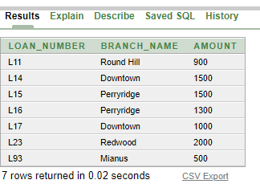

### Borrower

insert into borrower values(‘Hayes’, ‘L15’);

insert into borrower values(‘Jones’, ‘L17’);

insert into borrower values(‘Smith’, ‘L11’);

insert into borrower values(‘Smith’, ‘L23’);

insert into borrower values(‘William’, ‘L17’);

insert into borrower values(‘Adam’, ‘L16’);

insert into borrower values(‘Curry’, ‘L93’);

insert into borrower values(‘Jackson’, ‘L14’);

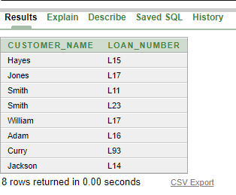

## Queries

1. *Give the customer name who has account but not any loan*

**ans.** (select customer_name from depositor) minus (select customer_name from borrower);

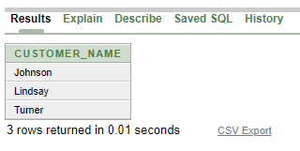

1. *Give the name of the customer who has either (10000-20000) or (30000-40000) in their account.*

**ans.** select customer_name from account natural join depositor where (balance between 10000 and 20000) or (balance between 30000 and 40000);

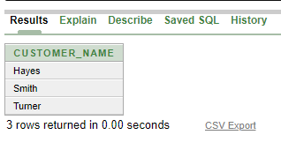

1. *Which branch has issued maximum amount of loan?*

**ans.** select branch_name from loan where amount = (select max(amount) from loan);

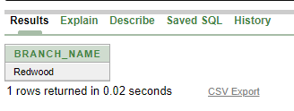

1. *Give the name of the customer who has maximum balance in their account.*

**ans.** select customer_name from account natural join depositor where balance = (select max(balance) from account);

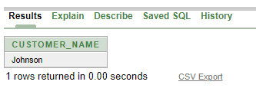

1. *Give the name of the customer who has opened an account in a city in which he is not located.*

**ans.** select distinct customer_name from (select * from depositor natural join account natural join branch natural join customer) where branch_city <> city;

